SCHOOL NAME: __________________________ EXAMINATION NO: ______________

SOUTH EAST EDUCATION DIVISION
2025 MALAWI SCHOOL CERTIFICATE OF EDUCATION MOCK EXAMINATION

CHEMISTRY

Subject Number: M038/I
Wednesday, 2nd April Time Allowed: 2 hours
8:00 – 10:00 am

PAPER I

THEORY
(100 marks)

Instructions
Question  Number | Tick if answered | Do not write in these columns
1
2
3
4
5
6
7
8
9
10
11
12
13
- This paper contains 8 printed pages.
Please check.

- Fill in your Examination Number and School Name at the top of each page.

- This paper contains two sections, A and B. In Section A there are ten short answer questions while Section B there are three restricted essay questions.

- Answer all the thirteen questions in the spaces provided.

- Use of electronic calculators is allowed.

- The maximum number of marks for each answer is indicated against each question.

- In the table provided on this page, tick against the number of question you have answered.

© 2025 SEED MOCK Turn over/…

Section A (70 marks)
Answer all the questions in this section

- a. Define rate of reaction.
______________________________________________________________________________________________________________________________________________ (1mark)
b. State any two ways of measuring rate of reaction.
_____________________________________________________________________________________________________________________________________________ (2marks)
c. Describe how a catalyst affects rate of reaction.
___________________________________________________________________________________________________________________________________________________________________________________________________________________________________________________________________________________________________ (4marks)

- Figure 1 is a diagram showing the electrolytic cell.
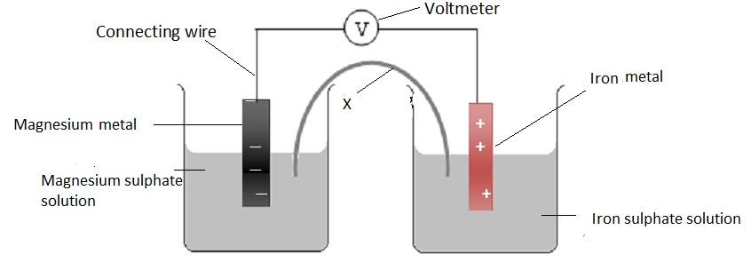
Figure 1
a. i. Name the part labelled X.
___________________________________________________________________ (1mark)
ii. State two functions of the part labelled X.
_____________________________________________________________________________________________________________________________________________ (2marks)
b. Write the half equation for the reaction taking place at the cathode.
___________________________________________________________________ (1mark)
- Write a line notation for the electrolytic cell in Figure 1.
_____________________________________________________________________________________________________________________________________________ (2marks)

Continued/…
- Calculate the standard e.m.f of the cell in figure 1 given that:
Mg²⁺ (aq) + 2e⁻ ↔ Mg(s) E⁰ = - 2.36V
Fe²⁺ (aq) + 2e⁻ ↔ Fe(s) E⁰ = - 0.44V

(3 marks)

3. a. Define hypothesis.
______________________________________________________________________________________________________________________________________________ (1 mark)
b. Explain the importance of evaluation in a scientific investigation.
_____________________________________________________________________________________________________________________________________________ (2 marks)
c. Describe how a copper ion (Cu ²⁺) can be tested.
________________________________________________________________________________________________________________________________________________________________________________________________________________________ (3 marks)
d. Describe any two social and economic importance of cycling wastes.
_____________________________________________________________________________________________________________________________________________ (2 marks)

4. a. What is the difference between a polar covalent bond and a non-polar covalent bond?
_____________________________________________________________________________________________________________________________________________ (2 marks)
- Explain the difference in boiling points between water (H₂O) and ethanol (CH₃CH₂OH).
___________________________________________________________________________________________________________________________________________________________________________________________________________________________________________________________________________________________________ (4 marks)
- What characteristic of a metal enables it to be used for making ringing bells?
__________________________________________________________________ (1 mark)

Continued/…
5. a. Explain the difference between concentration of an acid and strength of an acid.
_____________________________________________________________________________________________________________________________________________ (2 marks)
b. Write the products of the following acid – base reaction.
i. HSO₄⁻ (aq) + NH₃ (l) → ___________ + _________ (2 marks)

c. State any two uses of Ammonia
_____________________________________________________________________________________________________________________________________________ (2 marks)

6. Figure 2 shows structural formulae of some organic compounds.
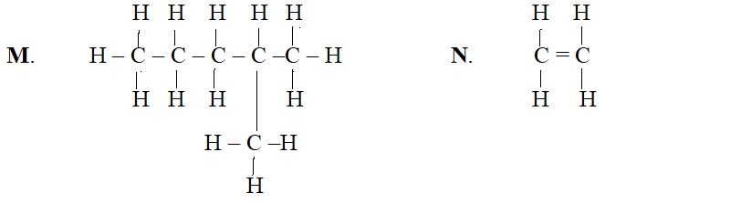
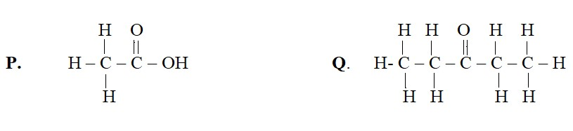
Figure 2
a. Name compounds M and Q.
M: _________________________________________________ (1 mark)
Q: _________________________________________________ (1 mark) b. Write down the condensed formula for compound M.
___________________________________________________ (1 mark)
c. State any two chemical properties of compound P.
_____________________________________________________________________________________________________________________________________________ (2 marks)
- Describe the test which can be conducted to identify organic compound Q from the other organic compounds.
________________________________________________________________________________________________________________________________________________________________________________________________________________________ (3 marks)
Continued/…

- Write a structural formula of an organic compound which is an isomer to compound Q.

(1mark)

7. a. 1.35g of Aluminium was heated in oxygen until there was no further gain in mass. The Aluminium oxide formed was weighed and mass was 3.75g. Work out the empirical formula of Aluminium oxide. (R.A.M: Al = 27, O = 16).

(7 marks)
b. Name two allotropes of carbon.
__________________________________________________________________ (2 marks)

8. a. State any two ways of removing temporary water hardness.
_____________________________________________________________________________________________________________________________________________ (2 marks)
b. With an aid of an equation describe how calcium sulphate can be formed by using
Sulphuric acid and calcium hydroxide
_________________________________________________________________________________________________________________________________________________________________________________________________________________________________________________________________________________________________________________________________________________________________________________________________________________________________________________________ (6 marks)

Continued/…
- a. State any two major sources of wastes.
___________________________________________________________________________________________________________________________________________ (2 marks)
b. Give any two disadvantages of using ‘incineration’ as one way of waste treatment.
___________________________________________________________________________________________________________________________________________ (2 marks)

- a. Define an alloy.
___________________________________________________________________________________________________________________________________________ (2 marks)
b. State any one property of brass.
_______________________________________________________________ (1mark)

SECTION B (30 MARKS)
Answer all questions in this section.
- a. Describe how permanent water hardness can be removed using ion-exchange method.
____________________________________________________________________________________________________________________________________________________________________________________________________________________________________________________________________________________________________________________________________________________________________________________________________________________________________________________________________________________________________________________________________ (4 marks)
b. With relevant equations, describe how chlorofluorocarbons (CFCs) deplete ozone
layer in the atmosphere.
__________________________________________________________________________________________________________________________________________________________________________________________________________________________________________________________________________________________________________________________________________________________________________________________________________________________________________________________________________________________________________________________________________________________________________________________________________________________________________________________________________________________ (6 marks)

Continued/…
- With an aid of a well labelled diagram, describe an experiment which could be used to determine the concentration of hydrochloric acid (HCl) solution using 0.1M sodium hydroxide (NaOH) solution.

___________________________________________________________________________________________________________________________________________________________________________________________________________________________________________________________________________________________________________________________________________________________________________________________________________________________________________________________________________________________________________________________________________________________________________________________________________________________________________________________________________________________________________________________________________________________________________________________________________________________________________________________________________________________________________________________________________________________________________________________________________________________________________________________________________________________________________________________________________________________________________________________________________________________________________________________________________________________________________________________________________________________________________________________________________________________________________________________________________________________________________________________________________________________________________________________________________________________________________________________________________________________________________________________________________________________________________________________________________________________________________________________________________________________________________________________________________________________________________________________ (10 marks)
Continued/…
13. With the aid of a diagram and equation, describe the indigenous production of ethanol from glucose (C₆ H₁₂ O₆).

____________________________________________________________________________________________________________________________________________________________________________________________________________________________________________________________________________________________________________________________________________________________________________________________________________________________________________________________________________________________________________________________________________________________________________________________________________________________________________________________________________________________________________________________________________________________________________________________________________________________________________________________________________________________________________________________________________________________________________________________________________________________________________________________________________________________________________________________________________________________________________________________________________________________________________________________________________________________________________________________________________________________________________________________________________________________________________________________________________________________________________________________________________________________________________________________________________________________________________________________________________________________________________________________________________________ (10 marks)
END OF QUESTION PAPER
NB: This paper contains 8 printed pages

